Product Requirements Document - CSPM

Introduction

Purpose:

The purpose of this document is to outline the product requirements for a cloud security platform that helps companies find and fix cloud infrastructure misconfigurations in AWS, GCP, and Azure environments.The aim is to provide an automated solution for detecting and fixing cloud misconfigurations in real-time, ensuring continuous security and compliance across multi-cloud environments. This product empowers cloud security engineers and DevOps teams to manage risks efficiently while minimizing manual intervention.

Scope:

The product scope includes a platform that continuously scans multi-cloud environments (AWS, GCP, Azure) to detect misconfigurations, vulnerabilities, and compliance violations. It will also provide real-time alerts, automated remediation recommendations, and a backend system for managing cloud security data. The solution will generate compliance and risk assessment reports that security teams can access to monitor their cloud infrastructure's security posture. The platform will focus on ease of integration, automation, and user-friendly interfaces to streamline cloud security management.

Audience:

Product development team
- Designers
- Developers
- Quality assurance engineers
- Project managers
- Cloud Security and Devops Team
- IT Compliance Officers
- CIOs/CTOs
- Cloud Infrastructure Architects

Problem Statement

Background:

Managing cloud infrastructure security in multi-cloud environments has become increasingly challenging as organizations scale their engineering operations. Misconfigurations in cloud resources are a leading cause of data breaches, but manual security checks are time-consuming and prone to errors. Despite the availability of various cloud security tools, many organizations lack real-time visibility into their cloud environments and struggle with maintaining continuous compliance with industry standards such as CIS benchmarks. Existing solutions often fall short in providing the automation and ease of use that security teams require to manage risks effectively.

Challenges:
- Ensuring continuous detection and remediation of cloud misconfigurations across AWS, GCP, and Azure environments.
- Automating security compliance and reducing reliance on manual audits to prevent security breaches.
- Providing an intuitive and user-friendly platform that integrates seamlessly into existing workflows for cloud security teams and DevOps engineers.

Objectives and Key Results (OKRs)
Product Vision:
For security engineers and DevOps teams who want to manage cloud infrastructure security and compliance across AWS, GCP, and Azure, the Cloud Secure Posture Management (CSPM) Tool is a solution that provides real-time insights into misconfigurations, compliance violations, and security risks. It empowers teams to automate remediation and stay compliant with industry standards, ensuring cloud security across all environments. Unlike existing alternatives, CSPM Tool offers deep integration with multiple cloud platforms, real-time compliance tracking, and robust automation features, making cloud security management seamless and proactive.
Goals:
- Reduce cloud misconfigurations and security risks.
- Improve cloud compliance adherence across AWS, GCP, and Azure.
- Increase user satisfaction by providing actionable insights and automation for cloud security management.

OKRs:
Objective 1: Enhance cloud infrastructure security posture by reducing misconfigurations.
- KR1: Reduce critical and high-severity cloud misconfigurations by 30% within 6 months.
- KR2: Increase the percentage of automated remediation actions by 25% within the next 6 months.
Objective 2: Improve cloud compliance adherence with industry standards like CIS Benchmarks, PCI-DSS, and HIPAA.
- KR1: Achieve 90% compliance with key security frameworks across all cloud environments within 4 months.
- KR2: Reduce the number of non-compliant resources by 20% through automated checks and alerts within 3 months.
Objective 3: Increase user engagement and efficiency through actionable insights and automation.
- KR1: Increase weekly active users (WAU) by 20% through enhanced user workflows and dashboard customization within 3 months.
- KR2: Achieve a user satisfaction score of 90% or higher based on in-app feedback and user surveys.

Jobs-to-be-Done (JTBD):
Security Engineers:
- Help me detect misconfigurations across multiple cloud platforms (AWS, GCP, Azure) in real time.
- Provide me with automated remediation options to fix security risks quickly and efficiently.
- Allow me to monitor and improve the security posture of my cloud infrastructure continuously.
DevOps Teams:
- Give me a unified view of cloud compliance across different environments to ensure industry standards are met.
- Help me identify security vulnerabilities and risks early, allowing me to remediate issues before they impact the business.
- Provide me with clear and actionable reports for auditing and internal compliance checks.

Market Research:
Growth:
The Cloud Security Posture Management (CSPM) market is experiencing rapid growth, driven by the increasing adoption of multi-cloud environments and the need for enhanced security and compliance solutions. With more organizations migrating their infrastructure to cloud platforms such as AWS, GCP, and Azure, the demand for automated compliance tracking and real-time security posture management has surged. This market growth is further fueled by stricter regulatory requirements like SOC 2, ISO 27001, and HIPAA, encouraging companies to seek automated solutions for cloud security and compliance management.
Competitor Analysis:
Leading CSPM providers such as Drata, Vanta, Sprinto, and OneTrust offer similar core functionalities, including compliance automation and continuous monitoring across major cloud platforms. However, while top competitors provide strong compliance support for standards like SOC 2, ISO 27001, and HIPAA, there is an opportunity to differentiate by enhancing remediation automation and offering a wider range of third-party integrations. Additionally, focusing on delivering a more streamlined, intuitive user experience—especially for organizations managing complex, multi-cloud infrastructures—presents a competitive advantage.

Feature | Drata | Vanta | Sprinto | OneTrust
Core Functionality | CSPM, compliance automation | CSPM, compliance automation | CSPM, compliance automation | GRC platform (wider scope)
Cloud Platform Support | AWS, GCP, Azure | AWS, GCP, Azure | AWS, GCP, Azure | AWS, GCP, Azure
Continuous Monitoring | Yes | Yes | Yes | Yes
Compliance Coverage | SOC 2, ISO 27001, HIPAA, PCI DSS | SOC 2, ISO 27001, HIPAA, PCI DSS | SOC 2, ISO 27001, HIPAA, PCI DSS | Broad range of frameworks (e.g., GDPR, CCPA)
Remediation Automation | Yes | Yes | Yes | Limited
AI/ML Capabilities | Yes | Yes | Yes | Yes
Third-Party Integrations | Yes | Yes | Yes | Yes

Identification of Users and Customers:

Users:
- Cloud Security Engineers:
  - Responsible for maintaining and monitoring the security of cloud environments, addressing misconfigurations, and ensuring compliance with security standards.
- DevOps Teams/Managers:
  - Focus on integrating security into CI/CD workflows, automating security checks during deployment, and ensuring seamless cloud infrastructure management.
- IT Compliance Officers:
  - Ensure that cloud environments adhere to regulatory standards and generate reports for audits.

- CIOs/CTOs (Chief Information Officers/Chief Technology Officers):
  - Oversee the overall security posture and compliance of the organisation’s cloud infrastructure, making strategic decisions based on security reports.

Customers:
- Medium to Large Enterprises:
  - Organisations using multi-cloud environments (AWS, GCP, Azure) that require continuous monitoring and compliance to manage their security risks efficiently.
- Financial Services Companies:
  - Heavily regulated industries where cloud compliance and security are critical, such as banking, insurance, and fintech companies.
- Technology and SaaS Companies:
  - Companies leveraging cloud platforms for software deployment, where cloud infrastructure security is a priority to ensure customer data protection.
- Managed Security Service Providers (MSSPs):
  - Companies offering security services to other organisations that need to monitor and manage multi-cloud environments for their clients.

User Personas and Use Cases

User Persona

Persona 1: Alex, Cloud Security Engineer

- Age: 32
- Occupation: Senior Cloud Security Engineer
- Tech Savviness: High; proficient with cloud platforms like AWS, GCP, and Azure
- Goals: To monitor and secure cloud environments by detecting misconfigurations and fixing vulnerabilities in real-time.
- Pain Points: Manually identifying and remediating cloud security issues is time-consuming and error-prone.

Persona 2: Ben, DevOps Manager

- Age: 40
- Occupation: DevOps Manager
- Tech Savviness: High; familiar with CI/CD pipelines and cloud infrastructure automation
- Goals: To integrate security checks into CI/CD pipelines and ensure all deployments comply with security best practices.
- Pain Points: Difficulty ensuring cloud infrastructure security without interrupting continuous deployments.

Persona 3: Maya, IT Compliance Officer

- Age: 45
- Occupation: IT Compliance Officer
- Tech Savviness: Moderate; uses security and compliance software regularly
- Goals: To generate compliance reports and ensure the company meets regulatory requirements across AWS, GCP, and Azure.
- Pain Points: Gathering data for compliance audits from multiple cloud providers is complex and time-consuming.

Persona 4: Tom, Chief Information Officer (CIO)

- Age: 50
- Occupation: CIO of a large enterprise
- Tech Savviness: High; oversees cloud infrastructure strategy and security
- Goals: To ensure the organization’s cloud environments are secure and compliant, and to make informed strategic decisions based on security reports.
- Pain Points: Gaining high-level visibility into the security posture of the entire cloud infrastructure is challenging, especially across multiple platforms.
.

Use Cases:

1. Alex, Cloud Security Engineer monitors cloud security posture
- Scenario: Alex is responsible for monitoring the security of his company’s cloud environments. He uses the platform to set up automated scanning for misconfigurations in AWS, GCP, and Azure. Alex configures real-time alerts for critical issues, allowing him to address vulnerabilities before they escalate.
- Outcome: Alex reduces manual intervention, proactively fixes security issues, and ensures that the cloud environment remains secure and compliant with industry standards.

2. Ben, DevOps Manager integrates security into CI/CD pipeline
- Scenario: Ben oversees the continuous integration and deployment of applications in a multi-cloud environment. He integrates the platform’s automated security checks into his CI/CD pipelines, ensuring that every deployment is scanned for misconfigurations before going live.
- Outcome: Ben ensures secure deployments without slowing down the development process, maintaining both speed and security in application releases.

3. Maya, IT Compliance Officer generates compliance reports
- Scenario: Maya needs to prepare compliance reports for an upcoming audit. She uses the platform to automatically generate detailed reports on the security posture of the company’s cloud environments, including adherence to CIS benchmarks and other regulatory standards.
- Outcome: Maya can quickly provide auditors with comprehensive compliance documentation, ensuring the company meets regulatory requirements without spending hours manually compiling reports.

4. Tom, CIO reviews cloud security reports for strategic decisions
- Scenario: Tom is tasked with overseeing the cloud infrastructure across the company’s global operations. He uses the platform’s monthly security reports to gain insight into high-risk areas, compliance status, and overall cloud security posture.
- Outcome: Tom is able to make informed strategic decisions about resource allocation and infrastructure improvements, ensuring that the company’s cloud environments remain secure and cost-efficient.

Feature Specifications and User Stories

Core Features
- Cloud Infrastructure Discovery: Automatically identifies and inventories cloud resources across AWS, GCP, and Azure environments.
- Configuration Assessment: Continuously evaluates cloud configurations against security best practices, industry standards, and regulatory requirements.
- Risk Assessment: Prioritises vulnerabilities based on severity, likelihood of exploitation, and potential impact.
- Compliance Monitoring: Tracks adherence to compliance frameworks and standards, providing detailed reports and evidence.
Advanced Features
- AI-Powered Threat Detection: Uses machine learning to identify anomalous behavior, suspicious activity, and potential security threats.
- Remediation Automation: Offers automated workflows to fix detected misconfigurations, reducing manual effort and improving response times.
- Vulnerability Management: Tracks and manages vulnerabilities, providing remediation guidance and patching recommendations.
- Data Loss Prevention (DLP): Monitors data flows and identifies potential data breaches or unauthorized access.
- Identity and Access Management (IAM) Assessment: Evaluates IAM policies and configurations to ensure proper access controls.
- Cloud Security Posture Score: Provides a quantitative measure of overall cloud security posture to track progress and identify areas for improvement.
Additional Features
- Customizable Dashboards: Allows for visualization of security posture, identification of trends, and tracking of metrics.
- Detailed Reporting: Generates comprehensive reports on security posture, compliance status, and risk assessments.
- Integration with Other Tools: Integrates with other security tools (e.g., SIEM, SOAR) for comprehensive threat management.
- CI/CD Integration: Integrates with CI/CD pipelines to enforce security checks during development and deployment.
- Automated Patch Management: While Scrut Automation might provide vulnerability recommendations, automated patch deployment might be a separate process.
- Configuration Drift Detection: This feature would require continuous monitoring and comparison of configurations against defined baselines.
- Policy-Based Remediation: Customizing remediation actions based on specific policies might involve manual configuration or scripting.
- Behavioral Analytics: This is a more advanced feature that requires data collection and analysis of user and entity behavior.
- Cloud Workload Protection: Protecting specific workloads like containers and serverless functions might be a specialized feature.
- Security Playbook Automation: Integrating with SOAR platforms for automated incident response is a more advanced capability.
- Risk Quantification: Providing a precise quantitative risk score might involve complex calculations and data analysis.

User Story 1: Cloud Infrastructure Discovery
Description:
This story involves automatic detection and inventory of cloud resources across AWS, GCP, and Azure environments.
Background:
Cloud Security Engineers need complete visibility of cloud infrastructure to ensure all resources are tracked for security assessment.
Why:
As a Cloud Security Engineer,
I want to automatically discover cloud resources,
So that I can ensure all assets are monitored for security risks.
Applicable User: Cloud Security Engineer
Applicable Roles: Cloud Security Engineer, DevOps Team
Acceptance Criteria:
- Scenario 1: Automatic Resource Discovery
  - Pre-condition(s): The system is connected to AWS, GCP, and Azure accounts.
  - Entry Point(s): Cloud Security Engineer → Cloud Environment Dashboard
  - Happy Flow:
    - The system automatically scans all connected cloud environments.
    - All discovered resources are inventoried and categorised by type.
    - A summary of discovered resources is displayed on the dashboard.
  - Alternate Flow: If no resources are found, the system displays a message: "No resources discovered."
  - Exception/Error Flow: If the scan fails due to permissions or connection errors, the system displays an error message: "Unable to discover cloud resources. Please check permissions."

User Story 2: Configuration Assessment
Description:
This story covers the continuous evaluation of cloud configurations against security best practices and compliance frameworks.
Background:
Cloud Security Engineers need to ensure all cloud resources are configured securely and meet compliance standards.
Why:
As a Cloud Security Engineer,
I want to assess cloud configurations continuously,
So that I can identify misconfigurations and security gaps.
Applicable User: Cloud Security Engineer
Applicable Roles: Cloud Security Engineer, Compliance Officer
Acceptance Criteria:
- Scenario 1: Continuous Configuration Assessment
  - Pre-condition(s): The system is connected to cloud environments.
  - Entry Point(s): Cloud Security Engineer → Configuration Dashboard
  - Happy Flow:
    - The system continuously evaluates cloud configurations against CIS benchmarks.
    - Misconfigurations are flagged based on predefined rules.
    - The system generates a compliance score for the overall configuration health.
  - Alternate Flow: If no misconfigurations are found, the system displays: "All configurations compliant."
  - Exception/Error Flow: If the assessment fails, the system displays: "Unable to assess configurations. Please retry."

User Story 3: Risk Assessment
Description:
This story covers the automated prioritization of cloud vulnerabilities based on severity, exploitation likelihood, and impact.
Background:
Cloud Security Engineers need to prioritize vulnerabilities efficiently to focus on the most critical security risks.
Why:
As a Cloud Security Engineer,
I want to prioritize vulnerabilities,
So that I can address the most critical security risks first.
Applicable User: Cloud Security Engineer
Applicable Roles: Cloud Security Engineer, Risk Management Team
Acceptance Criteria:
- Scenario 1: Risk-Based Vulnerability Prioritization
  - Pre-condition(s): The system has detected cloud vulnerabilities.
  - Entry Point(s): Cloud Security Engineer → Vulnerability Dashboard
  - Happy Flow:
    - The system assigns severity scores based on industry standards (CVSS).
    - Vulnerabilities are categorized by likelihood of exploitation and business impact.
    - The top 10 critical vulnerabilities are highlighted for immediate attention.
  - Alternate Flow: If no critical vulnerabilities are found, the system displays: "No critical vulnerabilities."
  - Exception/Error Flow: If risk assessment fails, the system displays: "Risk assessment unsuccessful."

User Story 4: AI-Powered Threat Detection
Description:
This story involves using AI to detect suspicious behavior and security threats across cloud environments.
Background:
Cloud Security Engineers need advanced threat detection to quickly identify emerging security risks.
Why:
As a Cloud Security Engineer,
I want AI-powered threat detection,
So that I can detect anomalies and potential security breaches in real time.
Applicable User: Cloud Security Engineer
Applicable Roles: Cloud Security Engineer, SOC Analyst
Acceptance Criteria:
- Scenario 1: AI-Based Anomaly Detection
  - Pre-condition(s): The system is monitoring the cloud environment.
  - Entry Point(s): Cloud Security Engineer → Threat Detection Dashboard
  - Happy Flow:
    - The system uses AI models to analyze cloud activity for anomalies.
    - Suspicious activity (e.g., unexpected login locations, excessive data transfer) is flagged.
    - The system generates alerts and suggests remediation actions.
  - Alternate Flow: If no threats are detected, the system displays: "No anomalies detected."
  - Exception/Error Flow: If threat detection fails, the system displays: "AI threat detection failed. Please check logs."

User Story 5: Cloud Security Posture Score
Description:
This story covers the generation of a quantitative cloud security posture score.
Background:
Cloud Security Engineers need a measurable security posture score to track improvements and identify areas of concern.
Why:
As a Cloud Security Engineer,
I want a security posture score,
So that I can understand the overall health of my cloud environment.
Applicable User: Cloud Security Engineer
Applicable Roles: Cloud Security Engineer, CISO
Acceptance Criteria:
- Scenario 1: Cloud Security Posture Scoring
  - Pre-condition(s): The system has access to cloud environment data.
  - Entry Point(s): Cloud Security Engineer → Posture Dashboard
  - Happy Flow:
    - The system calculates a security posture score based on configuration health and detected vulnerabilities.
    - The score is updated in real time as new issues are identified and resolved.
    - A detailed breakdown of the score is provided, highlighting areas for improvement.
  - Alternate Flow: If no issues are found, the system displays: "Excellent security posture."
  - Exception/Error Flow: If the score cannot be generated, the system displays: "Unable to calculate posture score."

User Story 6: Compliance Monitoring
Description:
This story covers the tracking of cloud compliance with industry standards and frameworks (e.g., PCI-DSS, HIPAA).
Background:
Compliance Officers need to continuously monitor cloud environments to ensure adherence to regulatory requirements.
Why:
As a Compliance Officer,
I want to monitor cloud compliance,
So that I can provide detailed reports and evidence for audits.
Applicable User: Compliance Officer
Applicable Roles: Compliance Officer, Cloud Security Engineer
Acceptance Criteria:
- Scenario 1: Continuous Compliance Monitoring
  - Pre-condition(s): The system is configured with compliance frameworks.
  - Entry Point(s): Compliance Officer → Compliance Dashboard
  - Happy Flow:
    - The system continuously evaluates cloud configurations against selected compliance frameworks.
    - Any non-compliance issues are flagged, with remediation suggestions.
    - The system generates compliance reports that can be exported for audit purposes.
  - Alternate Flow: If no issues are found, the system displays: "Compliant with selected frameworks."
  - Exception/Error Flow: If monitoring fails, the system displays: "Compliance monitoring failed."

Wireframes:

Login Page
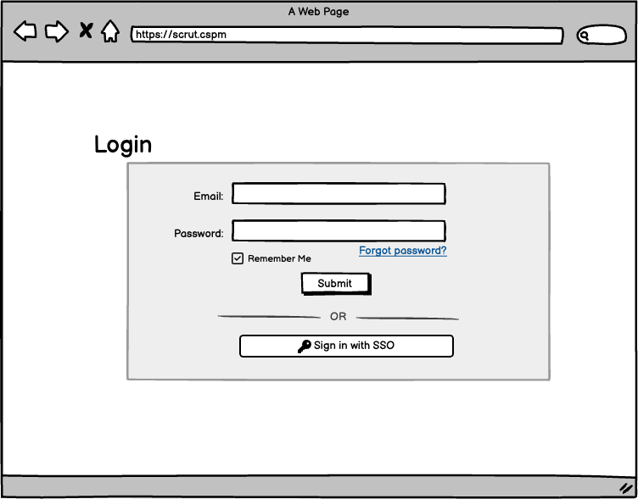

Dashboard :
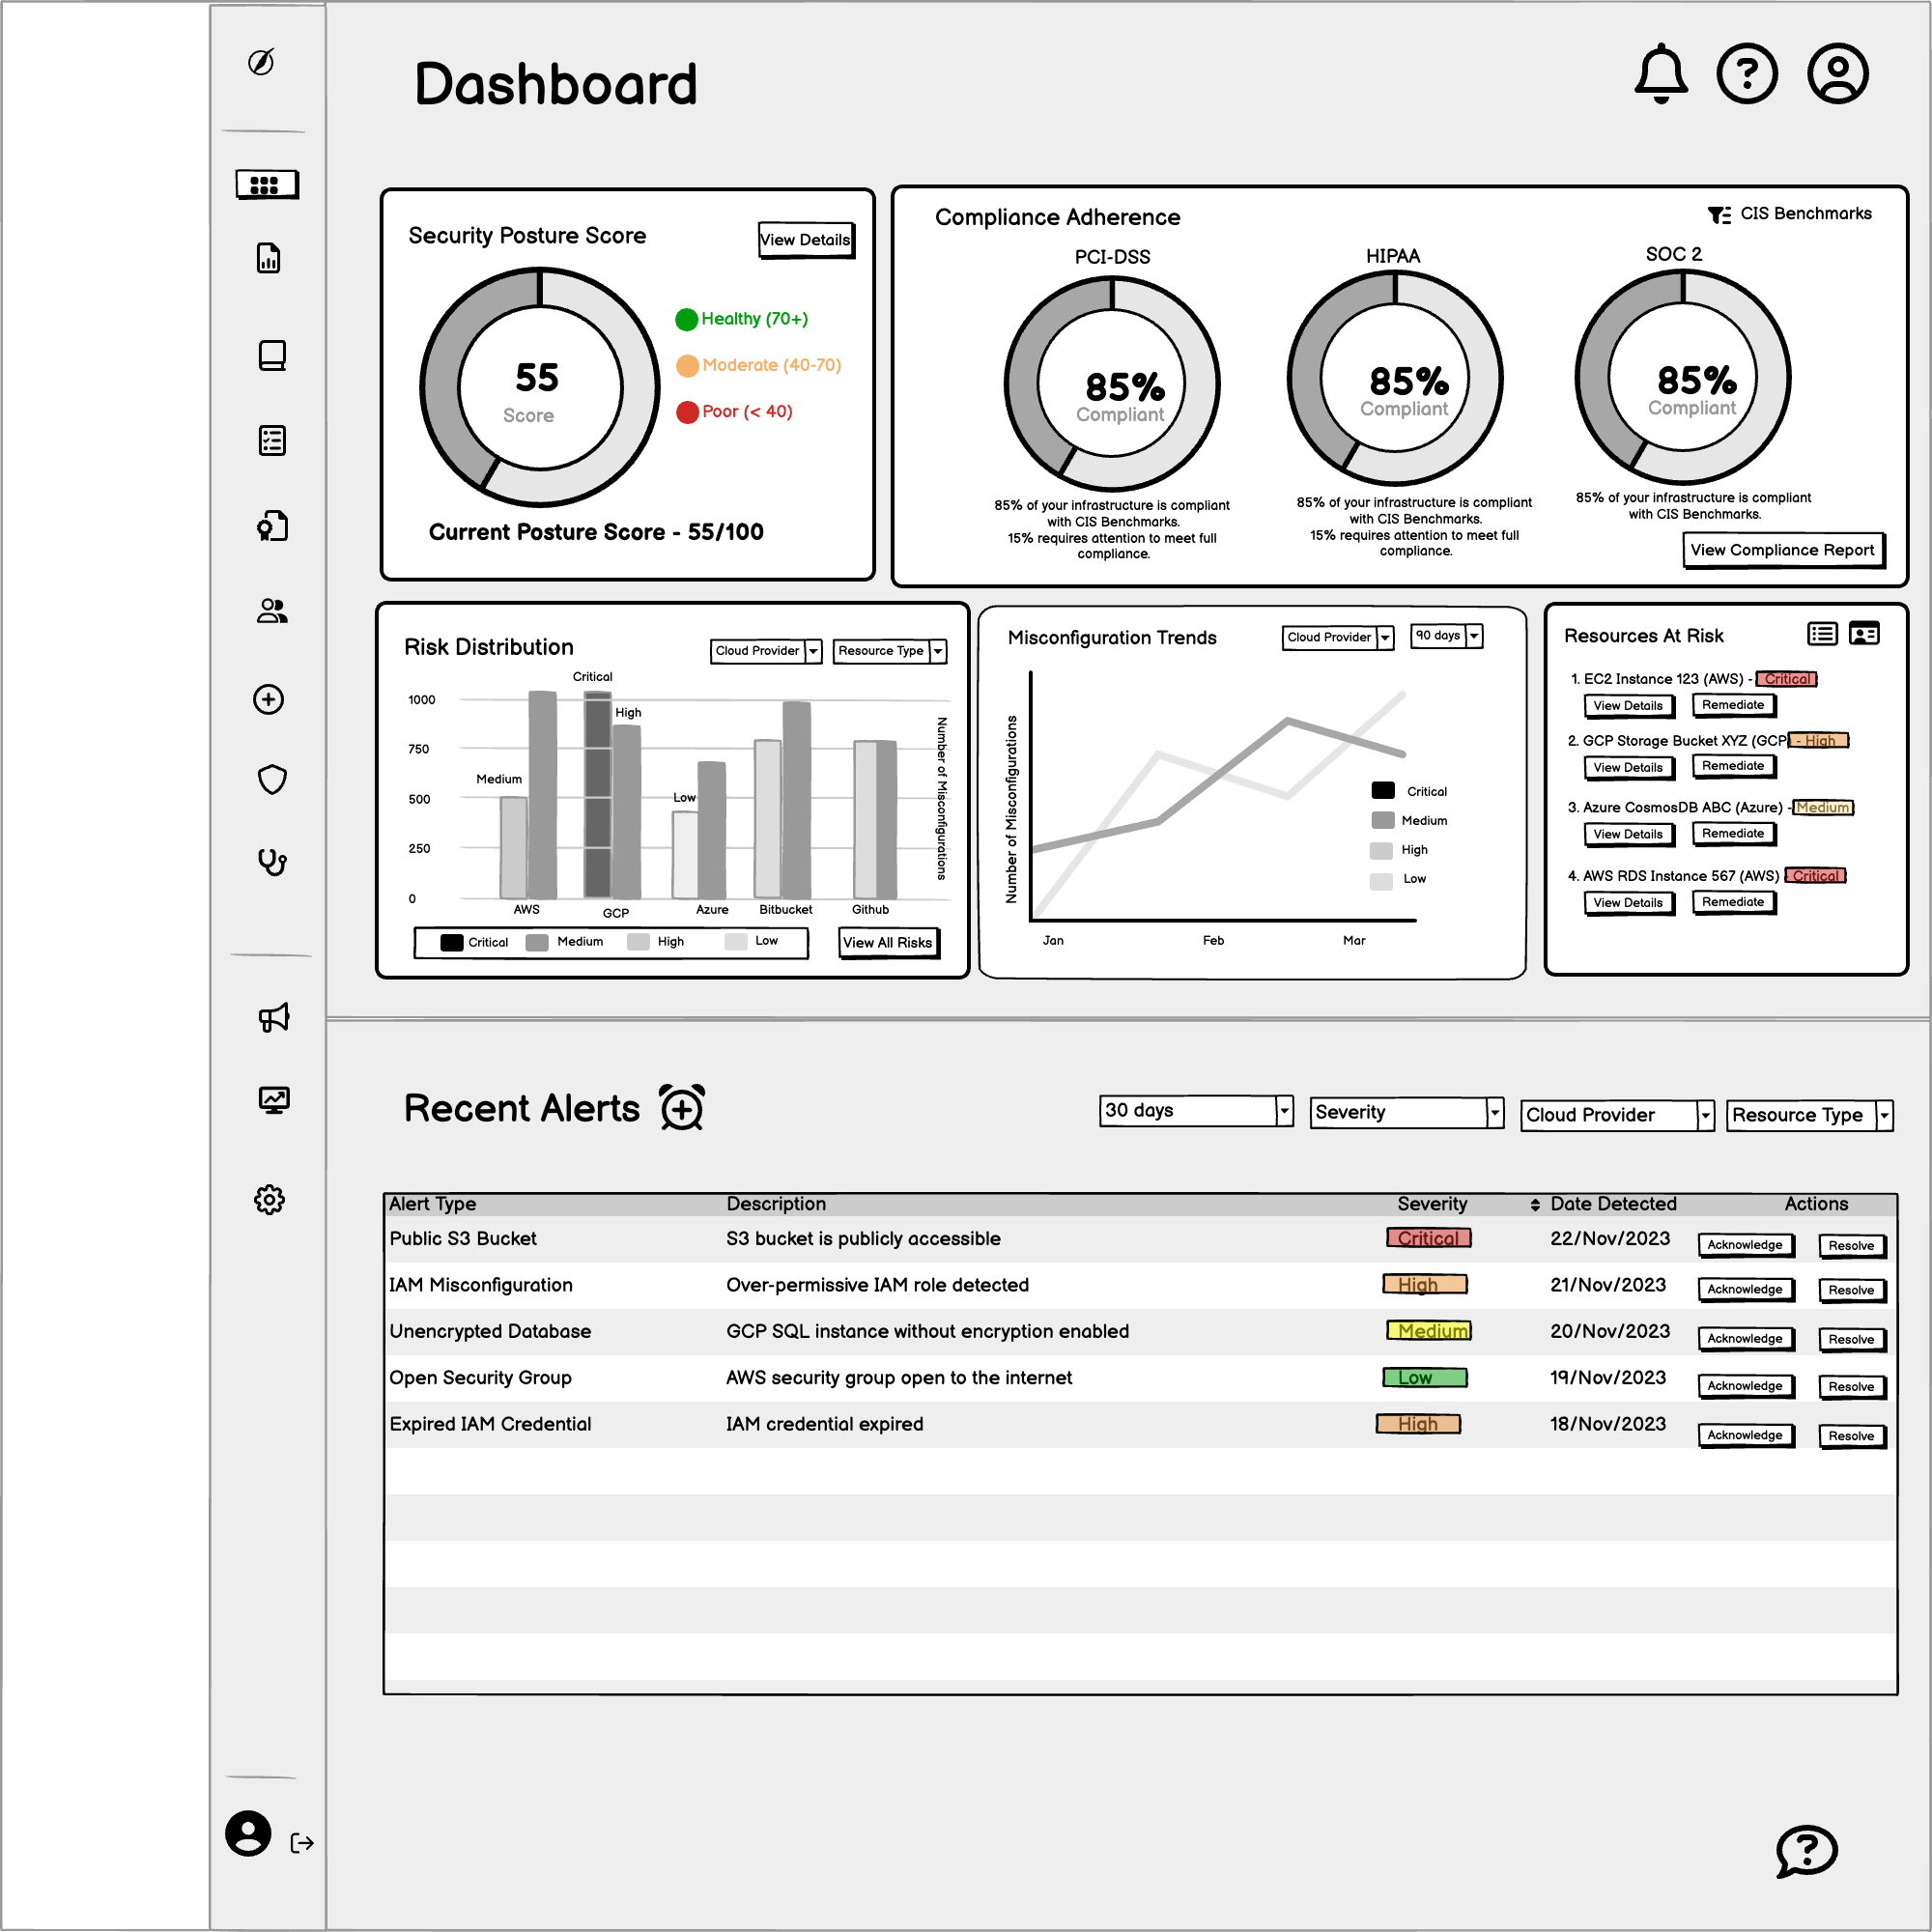

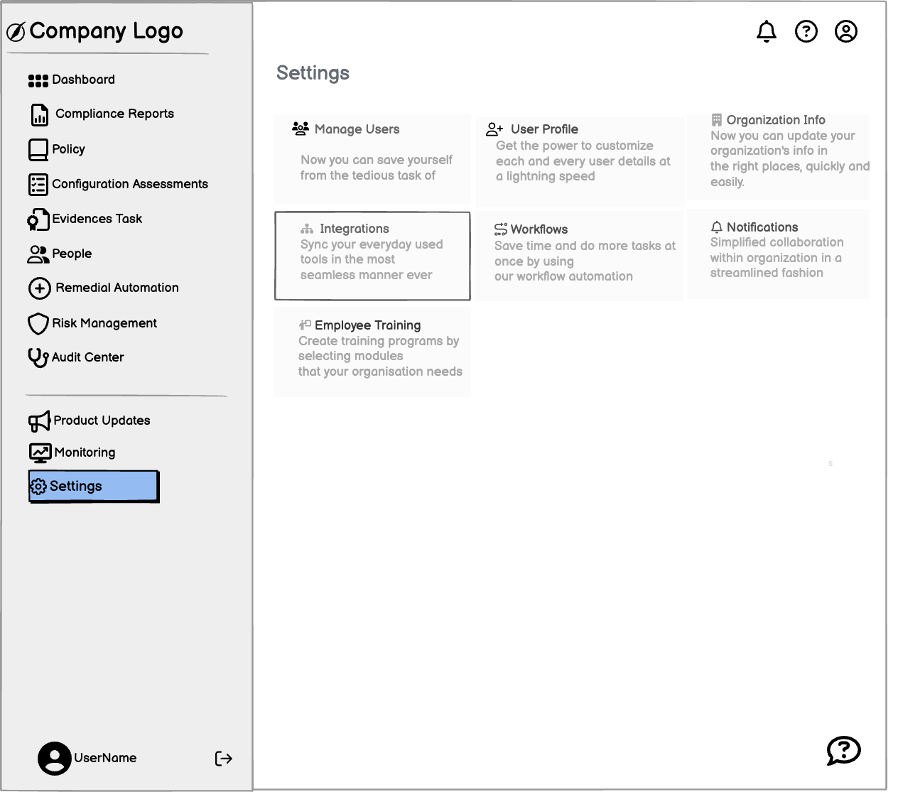
Settings :

Manage Integrations :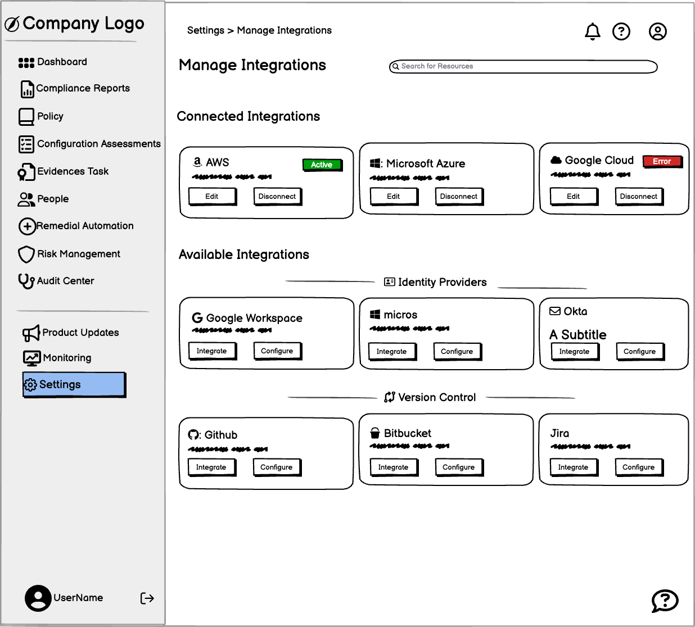

Monitoring :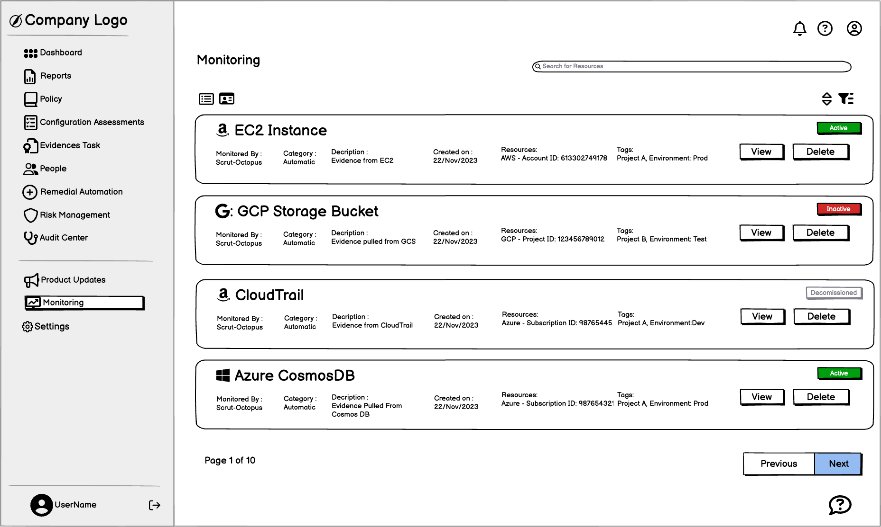

Compliance Reports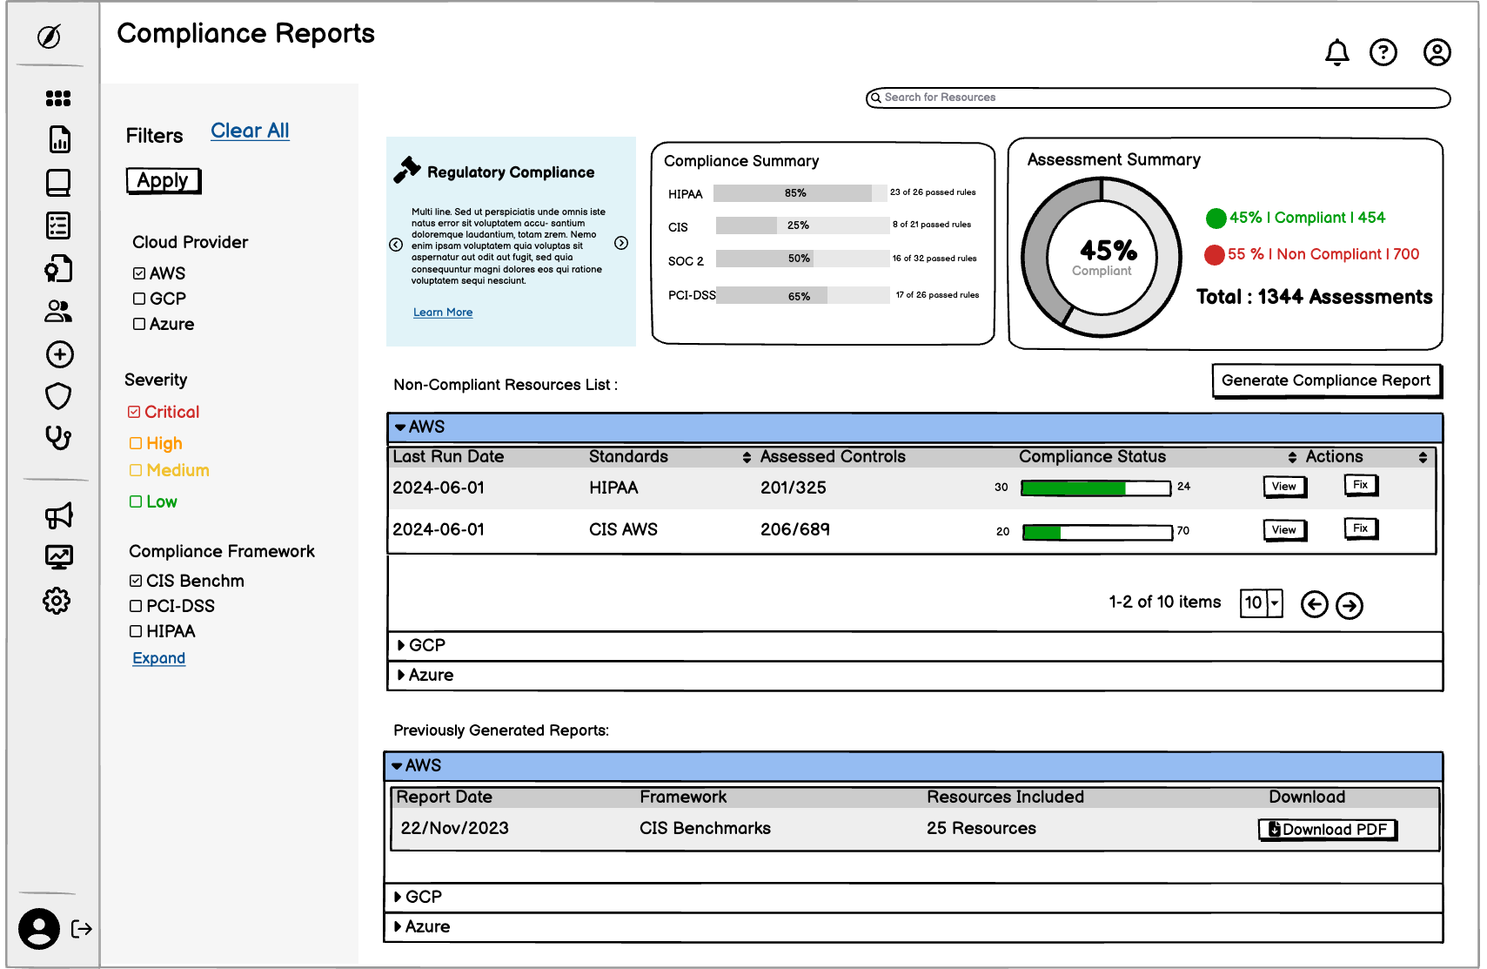

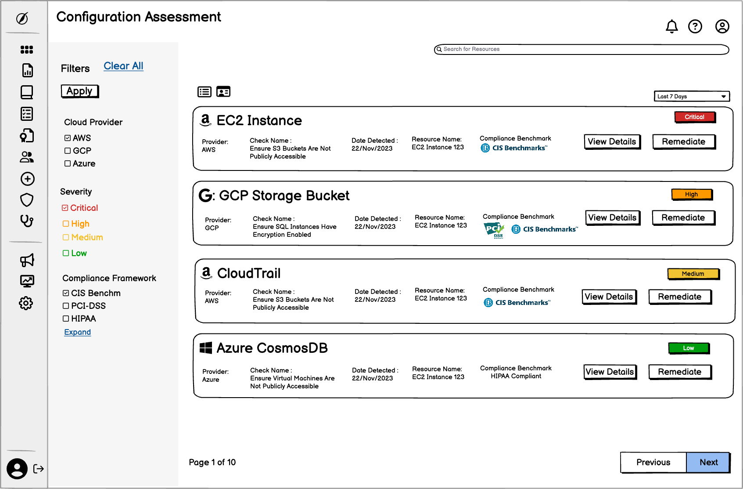
Configuration Assessments:
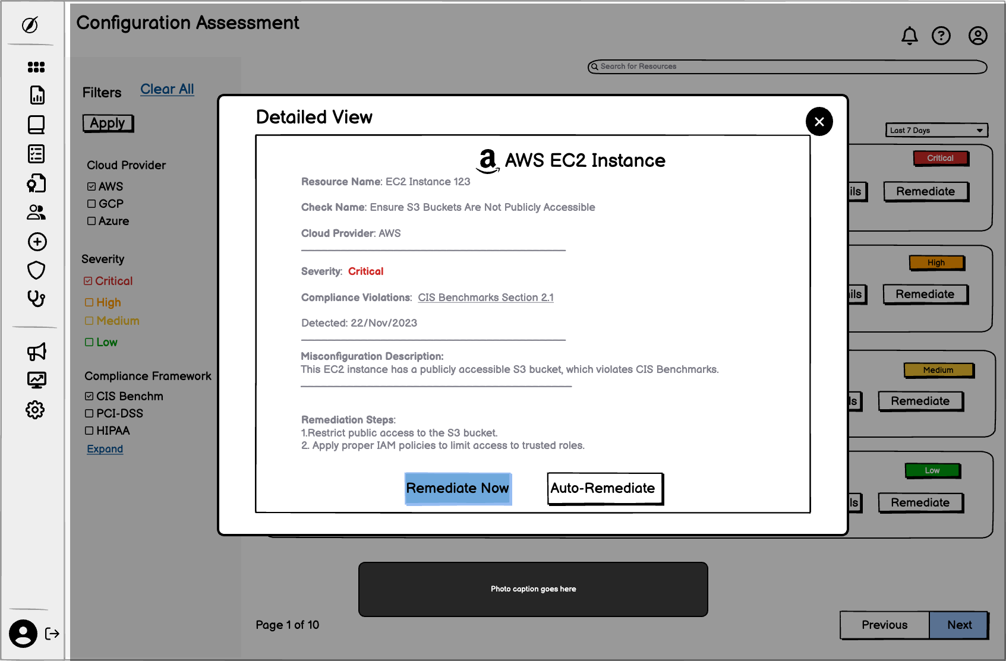

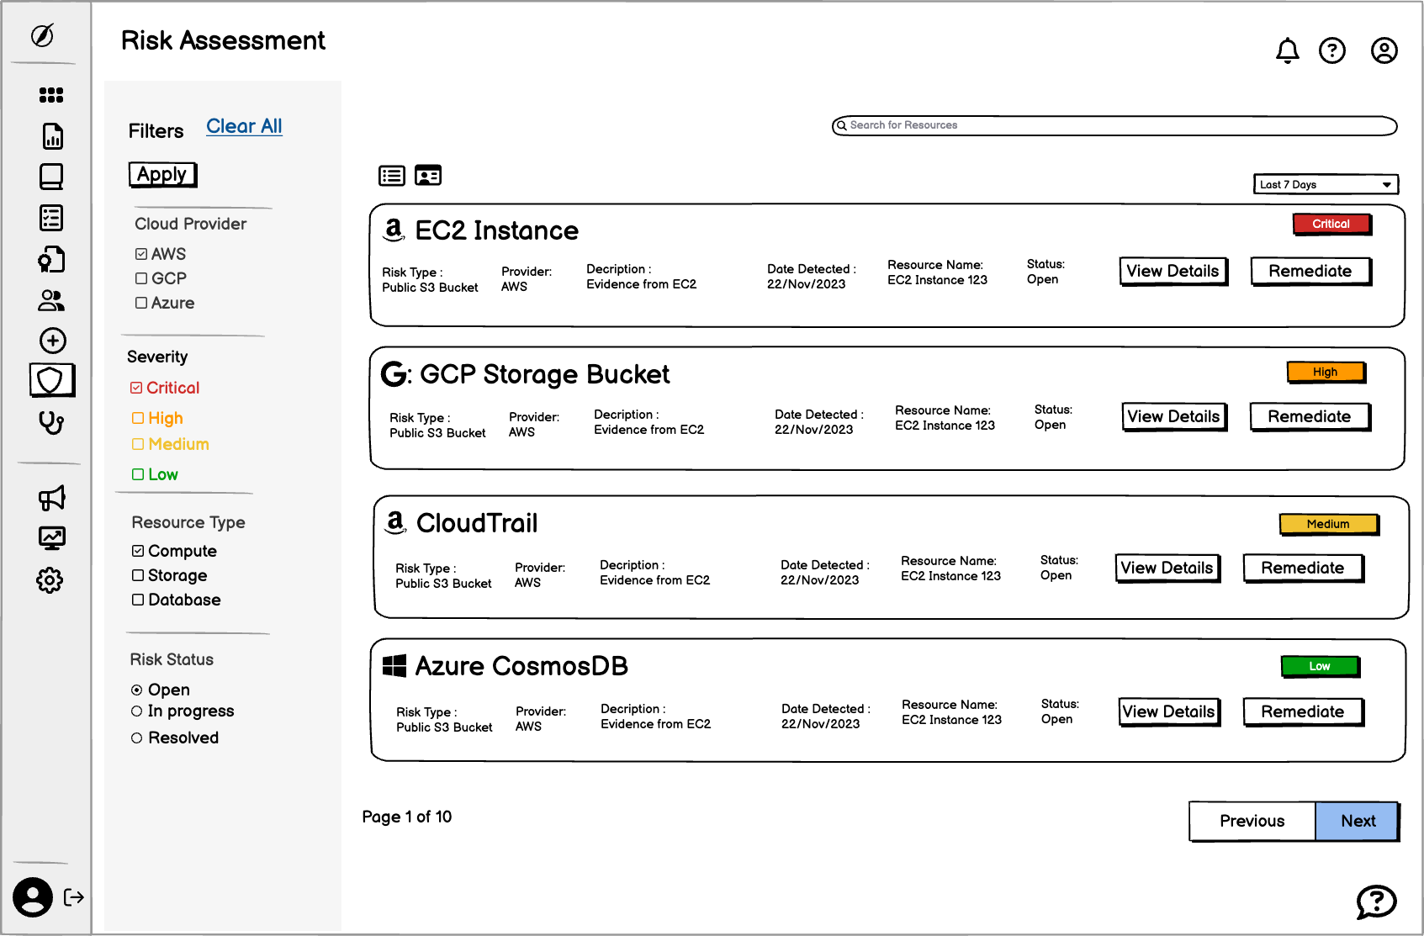
Risk Assessments:
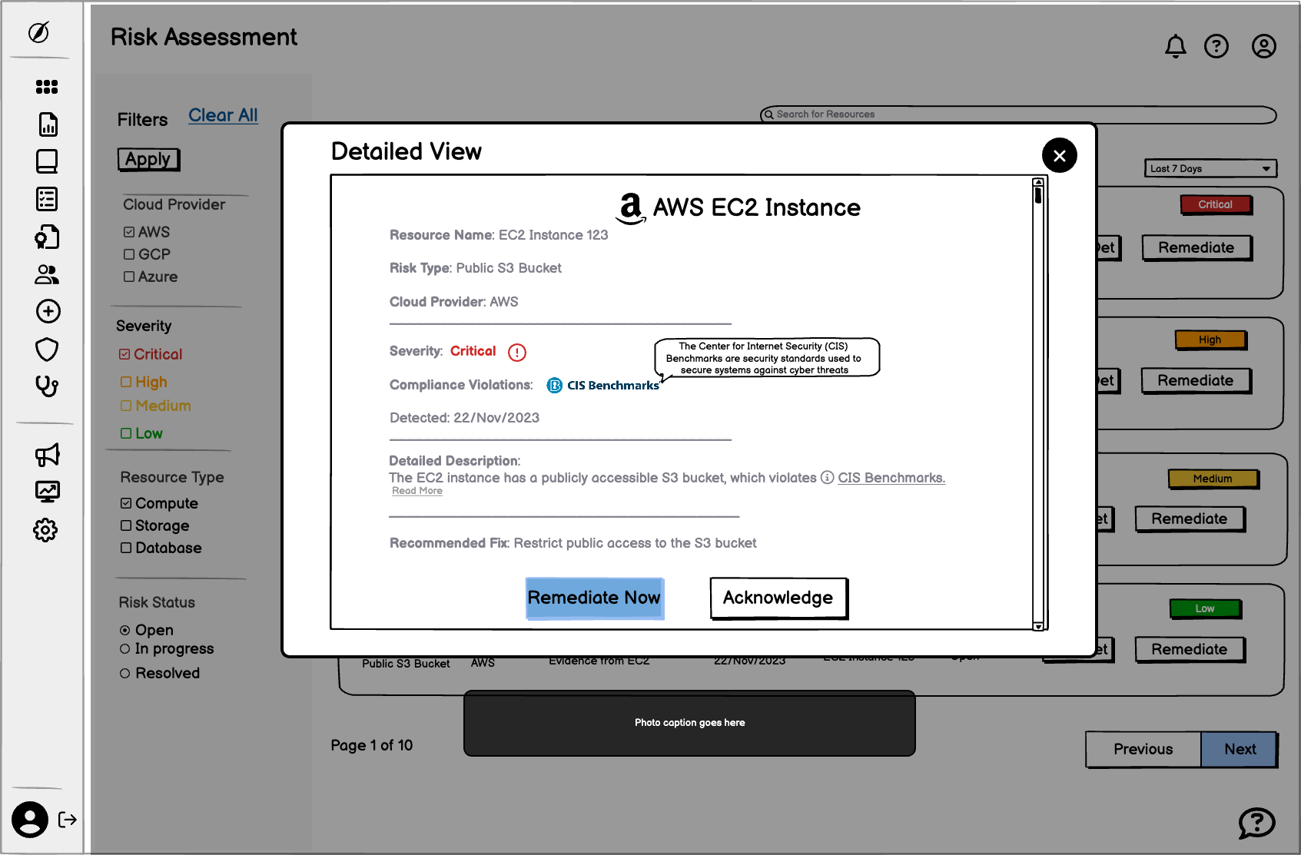

Remediation:
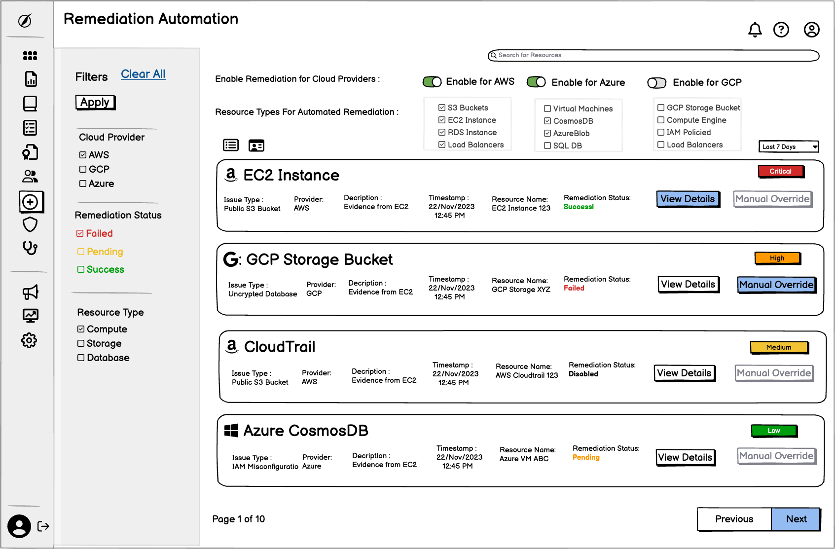

Functional Requirements:
- Provide real-time insights into cloud misconfigurations.
- Allow for compliance monitoring and adherence to industry standards.
- Automate remediation actions for security risks.
- Enable cloud resource discovery and inventory management.
Non-Functional Requirements:
- The app must load in under 2-3 seconds on both web and mobile platforms.
- The interface should be intuitive, ensuring ease of navigation and minimal user training.
- The system must c

Testing and Validation
Testing Strategy:
A comprehensive testing strategy will be implemented to ensure the tool meets all functional and non-functional requirements.
Alpha Testing:
The core functionalities will be verified internally to ensure they operate as expected. This includes testing across all supported cloud platforms (AWS, GCP, Azure), ensuring the tool runs smoothly and identifying critical bugs.
Beta Testing:
Limited external users will test the tool in real-world scenarios to provide feedback on usability, identify any remaining issues, and ensure the app meets the needs of security engineers and DevOps teams.
Results:
After both alpha and beta testing phases, user feedback will be gathered, bugs will be fixed, and performance metrics will be analyzed to ensure the tool is ready for full launch.

Dependencies and Assumptions
Dependencies:
- External Systems: Reliance on third-party services like Twilio or Firebase for sending notifications to users.
- Teams: The customer support team will assist with user onboarding and ongoing support, especially for cloud security engineers unfamiliar with similar tools.
Assumptions:
- Tech Savviness: Assume that security engineers and DevOps teams are comfortable navigating web-based security tools.
- Security Improvement: Assume that implementing the tool's features will lead to a significant improvement in cloud security posture, although this will be validated through user feedback and performance metrics.

Timeline and Milestones
Roadmap:
- Phase 1: Research and Planning (Month 1)
Conduct market analysis and user research to define the core product features and technical requirements. Finalize the Product Requirement Document (PRD) and technical architecture.
- Phase 2: Design and Prototyping (Month 2)
Develop high-fidelity wireframes and mockups to guide the user interface design. Create a clickable prototype for initial testing and gather user feedback.
- Phase 3: Development (Month 3-4)
Start backend and frontend development, focusing on building core functionalities like compliance monitoring, cloud discovery, and automated remediation. Ensure all key features are integrated.
- Phase 4: Testing and Validation (Month 5)
Conduct alpha testing with the internal team, followed by beta testing with a select group of external users. Collect feedback and address any major bugs or performance issues.
- Phase 5: Launch Preparation (Month 6)
Prepare for the official product launch by finalizing marketing strategies, performing final security audits, and ensuring compliance with all industry standards.
- Phase 6: Launch (Month 7)
Launch the CSPM tool to the market, initiate user acquisition campaigns, and closely monitor app performance for any immediate issues or bugs.
- Phase 7: Post-Launch and Iteration (Month 8-12)
Continuously monitor user feedback, track metrics such as acquisition, activation, and retention, and release updates or new features based on user needs.

Milestones:
- Milestone 1: Complete User Research and Market Analysis
  - Deliverable: Comprehensive research report
  - Deadline: End of Month 1
- Milestone 2: Finalize PRD and Technical Requirements
  - Deliverable: Completed PRD and technical documentation
  - Deadline: End of Month 1
- Milestone 3: Design Prototype Ready for Testing
  - Deliverable: High-fidelity prototype for user testing
  - Deadline: End of Month 2
- Milestone 4: Complete Backend and Frontend Development
  - Deliverable: Fully functional app with core features
  - Deadline: End of Month 4
- Milestone 5: Conduct Alpha and Beta Testing
  - Deliverable: Testing reports and bug fixes
  - Deadline: End of Month 5
- Milestone 6: Finalize Marketing and Launch Preparations
  - Deliverable: Marketing materials and launch plan
  - Deadline: End of Month 6
- Milestone 7: Official Product Launch
  - Deliverable: Live app available for download
  - Deadline: Beginning of Month 7
- Milestone 8: Post-Launch Metrics Review and Iterations
  - Deliverable: Regular updates, new features, and performance improvements
  - Deadline: Month 8-12

